21st Annual

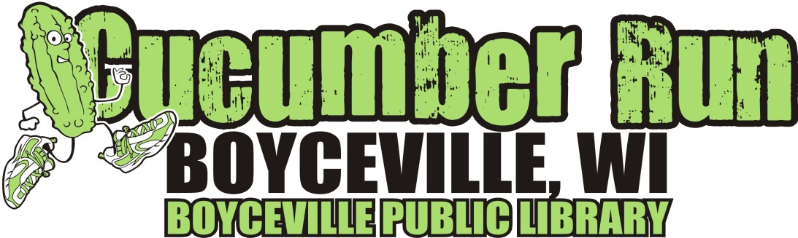

5K run/walk, 1-mile kids fun run

(adults welcome to participate in 1 mile but awards only for kids 12 and under)
Date: Saturday, 8/20/22 Donations made by:
Time: 8:30am Ohly
Register by 8/3/22 to guarantee T-shirt Marketplace Foods
Walmart
Late registration starts at 7:30am

Location: All races start and finish at Boyceville Middle School, located on Tiffany Street, just West of Hwy 79. Both runs will be loop runs.

Entry fee: $20.00 Proceeds benefit the Boyceville Public Library
Make checks payable to: Friends of the Boyceville Library
Mail to: Boyceville Public Library, PO Box 129, Boyceville, WI 54725 - By 8/3/22 to guarantee T-shirt

For more information: call 715-643-2106 or e-mail boycevillepl@boycevillelibrary.org

T-shirt size
Men’s sizes: Small___ Medium___ Large___ X-Large___

Youth sizes: X-Small(4)___ Small(6/8)___ Medium(10/12)___ Large(14/16)___ X-Large(18/20)___

Name________________________________________________________________

Address______________________________________________________________

City________________________________ State______ Zip_____________________

e-mail address__________________________________________________________

Phone_______________________________Gender__________ Age if in 1 mile________
5K 1 Mile Run/Walk

Waiver: I hereby waive and release any and all claims for damages that I may incur as a result of my participation in this race, knowing it is an athletic event on public roads.

Signature (participant)__________________________________________________
Signature of parent or guardian (if participant is under 18 years of age):

